|  |  |  |  |
| --- | --- | --- | --- |
| **Qualification details** | | | |
| **Training Package Code and Title** | ICT - Information and Communications Technology (Version 8.1) | | |
| **Qualification National Code and Title** | ICT50220 Diploma of information Technology (Release 2) | **State code** | BGJ4 |
| **Assessment Title** | Assessment Project Three (Individual Project) | | |
| **Unit National Code & Title** | ICTPRG535 Build advanced user interfaces | | |
| ICTPRG547 Apply advanced programming skills in another language | | |
| ICTICT517 Match ICT needs with the strategic direction of the organisation | | |

|  |  |  |  |  |  |  |
| --- | --- | --- | --- | --- | --- | --- |
| **Date Due** | Week Eighteen | | **Date Received** | |  | |
| **Student Name** | Riley Wilson | | | | | |
| **Student Declaration** | I declare that the evidence submitted is my own work: | | | | | |
| **Assessor Name** |  | | | | | |
| **Assessment Decision** | Satisfactory | | | Not Yet Satisfactory | | |
| **Assessor Signature** |  | | | **Date** | |  |
| **Is student eligible for reassessment (Re-sit)?** | No | Yes | | **Re-assessment Date:** | | Week Twenty |

|  |  |  |  |
| --- | --- | --- | --- |
| **Feedback to student** | | | |
| *Via Blackboard (LMS) – Please check [Grade] section.* | | | |
| **Feedback from student** | | | |
| *Via Blackboard (LMS) – Please use [Comment] section during submission.* | | | |
| **Student signature** |  | **Date** |  |

|  |  |
| --- | --- |
| **Assessment Instructions** | |
| **TO THE ASSESSOR** |  |
| Type of Assessment | Individual Project |
| Duration of the assessment | 6 class sessions (Weeks 13-18) |
| Location of assessment | Classroom |
| Conditions | Assessor to ensure that the noise levels, natural interactions and time variances are maintained as it would be in the Software Development industry.  Learners are required to complete the required tasks in class and submit the required documentation electronically via Blackboard |
| Elements and Criteria | As detailed in the assessment plan  You are required to make sure that all students meet the elements, performance criteria and oral communication items as outlined in the provided solution |
| **TO THE STUDENT** |  |
| Purpose of Assessment | You are required to show you can:  ICTPRG535 Build advanced user interfaces   * Plan and design a UI solution according to organisational requirements, * Apply interactions designs and implement validation requirements against the design plan, * Create and display the UI with graphics according to UI requirements.   ICTPRG547 Apply advanced programming skills in another language   * Code advanced data structures using hashing, sorting and searching algorithms, * Apply third party libraries and communication technologies for data exchange, * Test and evaluate the code to resolve logical and syntactical designs flaws, * Create and document the application according to technical specifications.   ICTICT517 Match ICT needs with the strategic direction of the organisation   * Interpret, analysis and report the strategic organisational plan * Propose and document changes for the implementation of a ICT system * Provide action plan and schedule   The student must demonstrate the ability to complete the tasks outlined in this assessment and is expected to use systematic analytical processes and effect time management to meet the goals/deadlines outlined in the DAP. |

|  |  |
| --- | --- |
| Allowable Materials | Blackboard Topics, SDLC, Weekly readings (PDF), Example programs and Independent Outside of Class Activities |
| Required Resources | Web links and example code can be downloaded from the Blackboard portal.  PC with Notepad++, Visual Studio, GitHub, MSOffice.  Internet Access to GitHub and www.citems.com.au/ |
| Reasonable Adjustment | In some circumstances, adjustments to assessments may be made for you. If you require support for literacy and numeracy issues; support for hearing, sight or mobility issues; change to assessment times/venues; use of special or adaptive technology; considerations relating to age, gender and cultural beliefs; format of assessment materials; or presence of a scribe you need to inform your lecturer. |
| Assessment Submission | All questions and programming activities must be attempted. All written answers must be submitted in this assessment document in the appropriate space.  Use of research tools and peers in formulating answers are acceptable – but work submitted must be your own work.  Final project documentation is to be uploaded to the appropriate area in the Blackboard course created for this unit.  If you are marked as NYS (Not Yet Satisfactory) on your first attempt, you will be provided with another opportunity to re-attempt the assessment. |
| Portfolio Description | A project of web coding tasks and written questions which should be completed in class and finished in the students’ own time on a weekly basis as per the Delivery and Assessment schedule.  Question 1 – Project Specification  Question 2 – Strategic Objectives Evaluation  Question 3 – Design Approval  Question 4 – General Interface Programming Criteria (Dictionary)  Question 5 – Admin Interface Programming Criteria  Question 6 – General Interface Programming Criteria (SortedDictionary)  Question 7 – Admin Interface Programming Criteria  Question 8 – Testing and Code Optimisation  Question 9 – Implementation Plan  Question 10 – Demonstration, Feedback and Signoff |

# Scenario

You are employed as the Senior Programmer with CITE Managed Services, and you have been assigned the Master File Project for an organisation called Malin Space Science Systems (MSSS). This project will require the planning and development of a multi-window application that will manage the staff details for the MSSS organisation. Ensure your development follows an Agile methodology that is recorded and maintained using your GitHub account. The details and criteria are provided in the following paragraphs.

You should consult with the CITE representative (your Lecturer) if you are unsure about any of the problems or questions in this assessment. Your primary research should focus on the resources on the Blackboard LMS and CITE web site, additional information can be collected from the Internet, ensure all sources are referenced in your submission. You must demonstrate your working applications before uploading to Blackboard, your Lecturer (Assessor) will sign off to ensure all the criteria are satisfied.

## Organisational Background

The staff at Malin are required to use their unique ID to gain access to all the facilities within the Malin organisation. All staff are issued a mobile phone and laptop as part of their employment conditions and induction training; this ensures they can work from any location utilising hot-desks and 5GHz Wi-Fi. The management at Malin’s ICT Security use the mobile phone numbers as the unique staff ID for login to security doors, science buildings, communication and server systems. Therefore, when a staff member arrives at work, they will use their staff mobile number to gain entry ito any building. Once they connect their laptop at a hot-desk they will logon to the computer network using the same mobile phone number.

The list of staff names and mobile numbers is stored on a secure cloud server in a single table data structure, which is separate to the encrypted password server that manages the passwords and monitoring systems. Since the original company was founded in London all mobile phones are issued using UK digits, so mobile numbers are nine digits starting with 07xxx, however the leading zero has been removed. Your application is to be a temporary solution whilst the development team are working on a global system that incorporates a single sign-on and biometric authentication. However, your solution is expected to be included in the global system.

## Application Requirements

Malin Space Science Systems requires a Windows Application which loads data from a .csv file into a read-only list box display. The user can then filter the data into a second list box for further examination. When a record is selected from the second list box the details are displayed in several related text boxes. The filter must be able to find and display partial results for both the ID number and the staff name. The Create, Update and Delete features must be performed in a second GUI. The Create option must prevent duplicate ID numbers, while the Update and Delete option must have a confirmation message (Status Strip). If a record is selected in the first general GUI and requires amendment the user can open the second admin GUI which will receive the data from the first general GUI. Refer to the following basic flowchart for UI actions and information flow. The full programming criteria for both applications are listed in Question 4, 5 and 6. The development can be completed using Windows Presentation Foundation or Windows Forms but must be consistent for both applications and GUIs. Any alternatives must be discussed and approved with the client (your Lecturer).

This assessment is a demonstration and comparison of two keyboard driven applications; therefore, all actions must utilise the Alt, Ctrl and CharKey combinations. The testing and optimization of the code is to demonstrate the most efficient file IO and search, then compare the two different data structures.

## UI Flowchart

**Start**

**End**

**Load data from Excel**

**Open General GUI & Display data in List box 1**

**Open Admin GUI**

**Filter Data**

**Display in List box 2**

**Display data from Textbox**

**Select and Display one data record**

**Enter ID for Display**

**Perform Edit Operations**

**Save Data and Close Admin GUI**

**No Data Found**

## Question 1 Project Specification

Provide a suitable description/explanation for each client requirement and UI actions and then insert your proposed UI design with labels that highlight all the major features for each GUI. Complete the following Project Specification template to answer this question.

|  |  |  |  |  |
| --- | --- | --- | --- | --- |
| Project Specification | | | | |
| Developer Name | Riley Wilson | | Date | 16/10/2023 |
| Application Requirements | | | | |
| Requirements | | Description | | |
| Windows Application | | Loads data from a .csv file into a read-only list box display | | |
| Second ListBox | | The user can then filter the data into a second list box for further examination | | |
| Second list box and Text Input Boxes | | When a record is selected from the second list box the details are displayed in several related text boxes | | |
| Text Input Filter | | The filter must be able to find and display partial results for both the ID number and the staff name | | |
| Create, Update and Delete features | | The Create, Update and Delete features must be performed in a second GUI | | |
| Create, Update and Delete option | | The Create option must prevent duplicate ID numbers, while the Update and Delete option must have a confirmation message (Status Strip) | | |
| General and Admin GUI | | If a record is selected in the first general GUI and requires amendment the user can open the second admin GUI which will receive the data from the first general GUI | | |
| Add additional rows as required | |  | | |
| General GUI Specification | | | | |
| Specification | | Description | | |
| 2 List Boxes | | 1 for displaying data and 2 for displaying filtered data | | |
| 2 Text Boxes | | Filter text boxes for ID and Name | | |
| 1 Label | | Label for listing keyboard input shortcuts | | |
| Add additional rows as required | |  | | |
| General GUI Design Diagram | | | | |
| How will the client application look and what GUI specifications are required? | | | | |
| Admin GUI Specification | | | | |
| Specification | | Description | | |
| 2 Text Boxes | | 1 for Staff ID Key and 2 for Staff Name Value | | |
| 1 Label | | Label for listing keyboard input shortcuts | | |
| Add additional rows as required | |  | | |
| Admin GUI Design Diagram | | | | |
| How will the client application look and what GUI specifications are required? | | | | |

## Question 2 Strategic Objectives Evaluation

Read the Organisational Background and Application Requirements for Malin Space Science Systems and answer the following questions. In this review you will highlight the current system and then formulate proposed changes your solution could have on the MSSS organisation. Complete the following Strategic Objectives Evaluation template to answer this question.

|  |  |  |  |
| --- | --- | --- | --- |
| Strategic Objectives Evaluation | | | |
| Project Name: | Malin-Space-Science-Systems | | |
| Developer Name | Riley Wilson | Date | 16/10/2023 |
| Current System Status | | | |
| List the ICT conditions for staff at MSSS?  All staff are issued a mobile phone and laptop as part of their employment conditions and induction training | | | |
| What are the current working conditions for staff at MSSS?  They can work from any location utilising hot-desks and 5GHz Wi-Fi | | | |
| List the current security protocols used by staff at MSSS?  The management at Malin’s ICT Security use the mobile phone numbers as the unique staff ID for login to security doors, science buildings, communication and server systems | | | |
| What Professional Development is offered for staff at MSSS?  The development team are working on a global system that incorporates a single sign-on and biometric authentication | | | |
| Proposed Changes | | | |
| List the effects of the proposed changes for the staff at MSSS?  Name and ID will be added to the list and will be compared with a dictionary and a sorted dictionary to see which gives the best results. Optimisation will also be done to make sure that it is ready for release | | | |
| List possible difficulties of the proposed changes for the staff at MSSS?  Data might have errors and duplicates may exist or a name or an ID column may be missing | | | |
| How might you schedule the implementation of the proposed changes?  By making an announcement Email and also scheduling a meeting about the changes | | | |
| How might you gather feedback on the proposed changes?  By sending Emails with a feedback form to employees asking for their feedback | | | |

## Question 3 Design Approval

Once you have complete questions 1 & 2 arrange for your document to be reviewed by the Lecturer/Assessor for approval, sign off and feedback before completing the development and testing.

* Question 1 Project Specification
* Question 2 Strategic Objectives Evaluation

|  |  |  |  |  |
| --- | --- | --- | --- | --- |
| Design Approval (Lecturer/Assessor use only) | | | | |
| Approver Name | Title | Signature | Date | Approved? |
| Stewart Godwin | Lecturer |  | 6/11/2023 | Yes |
|  |  |  |  |  |
| Lecturer Feedback | | | | |
|  | | | | |

Application Requirements

In the following questions you will develop/code/debug two separate solutions; these cannot be located in the same Project but must have a separate and distinct NameSpace. The first Windows Application will use a Dictionary data structure while the second Windows Application will use a Sorted Dictionary. Both applications must have the same code and method structures for all the criteria. You will be testing each application to determine the “best” option for the client.

## Question 4 General Interface Programming Criteria (Dictionary)

Your first programming task is to create the General GUI which will load the data and display records. The second task is to create the Admin GUI to perform Create, Update and Delete operations. The csv file can be obtained from your lecturer or downloaded from Blackboard.

### Create a Dictionary data structure with a TKey of type integer and a TValue of type string, name the new data structure “MasterFile”.

### Create a method that will read the data from the .csv file into the Dictionary data structure when the GUI loads.

### Create a method to display the Dictionary data into a non-selectable display only list box (ie read only).

### Create a method to filter the Staff Name data from the Dictionary into a second filtered and selectable list box. This method must use a text box input and update as each character is entered. The list box must reflect the filtered data in real time.

### Create a method to filter the Staff ID data from the Dictionary into the second filtered and selectable list box. This method must use a text box input and update as each number is entered. The list box must reflect the filtered data in real time.

### Create a method for the Staff Name text box which will clear the contents and place the focus into the Staff Name text box. Utilise a keyboard shortcut.

### Create a method for the Staff ID text box which will clear the contents and place the focus into the text box. Utilise a keyboard shortcut.

### Create a method for the filtered and selectable list box which will populate the two text boxes when a staff record is selected. Utilise the Tab and keyboard keys.

### Create a method that will open the Admin GUI when the Alt + A keys are pressed. Ensure the General GUI sends the currently selected Staff ID and Staff Name to the Admin GUI for Update and Delete purposes and is opened as modal. Create modified logic to open the Admin GUI to Create a new user when the Staff ID 77 and the Staff Name is empty. Read the appropriate criteria in the Admin GUI for further information.

1. Add suitable error trapping and user feedback via a status strip or similar to ensure a fully functional User Experience. Make all methods private and ensure the Dictionary is static and public.
2. Ensure all code is adequately commented. Map the programming criteria and features to your code/methods by adding comments above the method signatures. Ensure your code is compliant with the CITEMS coding standards (refer http://www.citems.com.au/).

## Question 5 Admin Interface Programming Criteria (Dictionary)

The Admin GUI must be in the same name space and solution folder as the General GUI from the previous question.

1. Create the Admin GUI with the following settings: GUI is model, all Control Box features are removed/hidden, then add two text boxes. The text box for the Staff ID should be read-only for Add, Update and Delete purposes.
2. Create a method that will receive the Staff ID from the General GUI and then populate text boxes with the related data.
3. Create a method that will create a new Staff ID and input the staff name from the related text box. The Staff ID must be unique starting with 77xxxxxxx while the staff name may be duplicated. The new staff member must be added to the Dictionary data structure.
4. Create a method that will Update the name of the current Staff ID.
5. Create a method that will Remove the current Staff ID and clear the text boxes.
6. Create a method that will save changes to the csv file, this method should be called as the Admin GUI closes.
7. Create a method that will close the Admin GUI when the Alt + L keys are pressed.
8. Add suitable error trapping and user feedback via a status strip or similar to ensure a fully functional User Experience. Make all methods private and ensure the Dictionary is updated.
9. Ensure all code is adequately commented. Map the programming criteria and features to your code/methods by adding comments above the method signatures. Ensure your code is compliant with the CITEMS and MS coding standards (refer http://www.citems.com.au/).

## Addendum

This development utilises keyboard input for all General and Admin GUI events, you are permitted to reassign the key combinations from those described in the list of criteria; however, ensure these are recorded/displayed for the user’s convenience.

## Question 6 General Interface Programming Criteria (Sorted Dictionary)

Your second programming task is to create the General GUI which will load the data and display records. The final task is to create the Admin GUI to perform Create, Update and Delete operations. The csv file can be obtained from your lecturer or downloaded from Blackboard.

### Create a SortedDictionary data structure with a TKey of type integer and a TValue of type string, name the new data structure “MasterFile”.

### Create a method that will read the data from the .csv file into the SortedDictionary data structure when the GUI loads.

### Create a method to display the SortedDictionary data into a non-selectable display only list box (ie read only).

### Create a method to filter the Staff Name data from the SortedDictionary into a second filtered and selectable list box. This method must use a text box input and update as each character is entered. The list box must reflect the filtered data in real time.

### Create a method to filter the Staff ID data from the SortedDictionary into the second filtered and selectable list box. This method must use a text box input and update as each number is entered. The list box must reflect the filtered data in real time.

### Create a method for the Staff Name text box which will clear the contents and place the focus into the Staff Name text box. Utilise a keyboard shortcut.

### Create a method for the Staff ID text box which will clear the contents and place the focus into the text box. Utilise a keyboard shortcut.

### Create a method for the filtered and selectable list box which will populate the two text boxes when a staff record is selected. Utilise the Tab and keyboard keys.

### Create a method that will open the Admin GUI when the Alt + A keys are pressed. Ensure the General GUI sends the currently selected Staff ID and Staff Name to the Admin GUI for Update and Delete purposes and is opened as modal. Create modified logic to open the Admin GUI to Create a new user when the Staff ID 77 and the Staff Name is empty. Read the appropriate criteria in the Admin GUI for further information.

1. Add suitable error trapping and user feedback via a status strip or similar to ensure a fully functional User Experience. Make all methods private and ensure the Dictionary is static and public.
2. Ensure all code is adequately commented. Map the programming criteria and features to your code/methods by adding comments above the method signatures. Ensure your code is compliant with the CITEMS coding standards (refer http://www.citems.com.au/).

## Question 7 Admin Form Programming Criteria (Sorted Dictionary)

The Admin GUI must be in the same name space and solution folder as the General GUI from the previous question.

1. Create the Admin GUI with the following settings: Form is model, all Control Box features are removed/hidden, then add two text boxes. The text box for the Staff ID should be read-only for Update and Delete purposes.
2. Create a method that will receive the Staff ID from the General GUI and then populate text boxes with the related data.
3. Create a method that will create a new Staff ID and input the staff name from the related text box. The Staff ID must be unique starting with 77xxxxxxx while the staff name may be duplicated. The new staff member must be added to the SortedDictionary data structure.
4. Create a method that will Update the name of the current Staff ID.
5. Create a method that will Remove the current Staff ID and clear the text boxes.
6. Create a method that will save changes to the csv file, this method should be called as the Admin GUI closes.
7. Create a method that will close the Admin GUI when the Alt + L keys are pressed.
8. Add suitable error trapping and user feedback via a status strip or similar to ensure a fully functional User Experience. Make all methods private and ensure the SortedDictionary is updated.
9. Ensure all code is adequately commented. Map the programming criteria and features to your code/methods by adding comments above the method signatures. Ensure your code is compliant with the CITEMS and MS coding standards (refer http://www.citems.com.au/).

## Addendum

This development utilises keyboard input for all General and Admin GUI events, you are permitted to reassign the key combinations from those described in the list of criteria, ensure these are recorded/displayed for the user’s convenience.

## Question 8 Testing and Code Optimisation

### File IO Optimisation

Ensure your code is error free and functions correctly, then test the method code for the major iterative File IO structures in the general and admin interfaces, ensure you record the performance details. Research alternatives to determine if your code is the best solution for reading and writing CSV files. Modify and optimise your methods as required, comment out older/slower code.

### Data Structure Optimisation

For each data structure run optimisation tests to determine the most efficient operational performance. The Dictionary<T,V> data structure represents a basic hash table , while the alternative is the SortedDictionary<T,V> which is a basic binary search tree implementation. Record your results and determine the best performance; add comments to the code with the best and worst performance.

Your Test and Code Optimisation report must include appropriate evidence that your multi-window application functions as expected (references to screen captures) and the code has been optimised. Complete the following Test and Code Optimisation report template to answer this question.

|  |  |  |  |  |
| --- | --- | --- | --- | --- |
| Test and Code Optimisation | | | | |
| Developer Name | Riley Wilson | | **Date** | 30/10/2023 |
| **File IO Testing** | | | | |
| Read CSV | Description | Optimisation | | |
| LoadDictionaryData() | Sorted Dictionary | LoadDictionaryData: 8ms, 83724 Ticks | | |
| LoadDictionaryData() | Dictionary | LoadDictionaryData: 2ms, 23021 Ticks | | |
| Write CSV | Description | Optimisation | | |
| SaveDictionary() | Sorted Dictionary | SaveDictionary: 2ms, 23389 Ticks | | |
| SaveDictionary() | Dictionary | SaveDictionary: 1ms, 16767 Ticks | | |
| **Data Structure Testing** | | | | |
| Dictionary<> | Description/Definition | Performance (Big O) | | |
| CreateStaffRecord() | Create a staff record | CreateStaffRecord: 1ms, 18910 Ticks | | |
| UpdateStaffRecord() | Update existing staff record | UpdateStaffRecord: 1ms, 17383 Ticks | | |
| DeleteStaffRecord() | Delete existing staff record | DeleteStaffRecord: 1ms, 16767 Ticks | | |
| SortedDictionary<> | Description/Definition | Performance (Big O) | | |
| CreateStaffRecord() | Create a staff record | CreateStaffRecord: 2ms, 22373 Ticks | | |
| UpdateStaffRecord() | Update existing staff record | UpdateStaffRecord: 1ms, 19750 Ticks | | |
| DeleteStaffRecord() | Delete existing staff record | DeleteStaffRecord: 2ms, 23389 Ticks | | |

**Dictionary:**

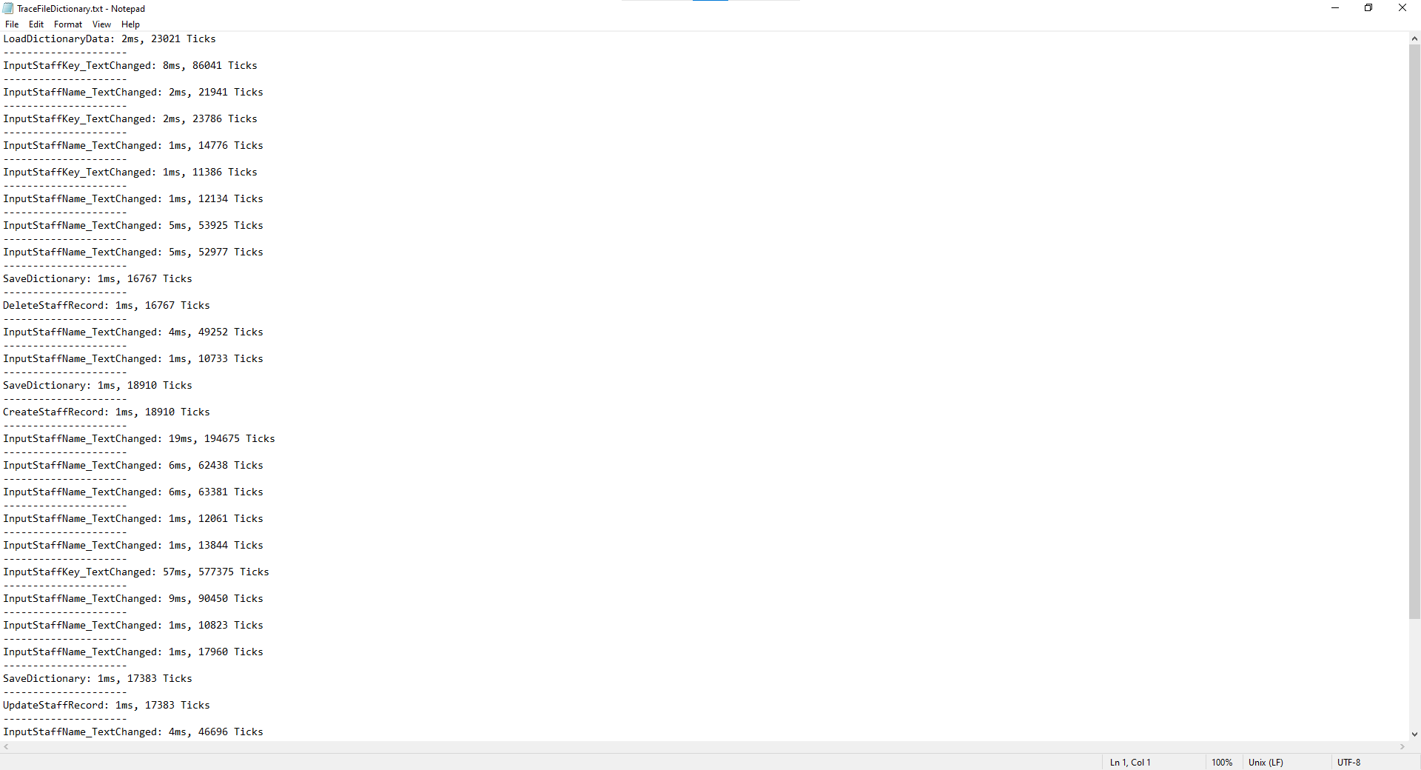

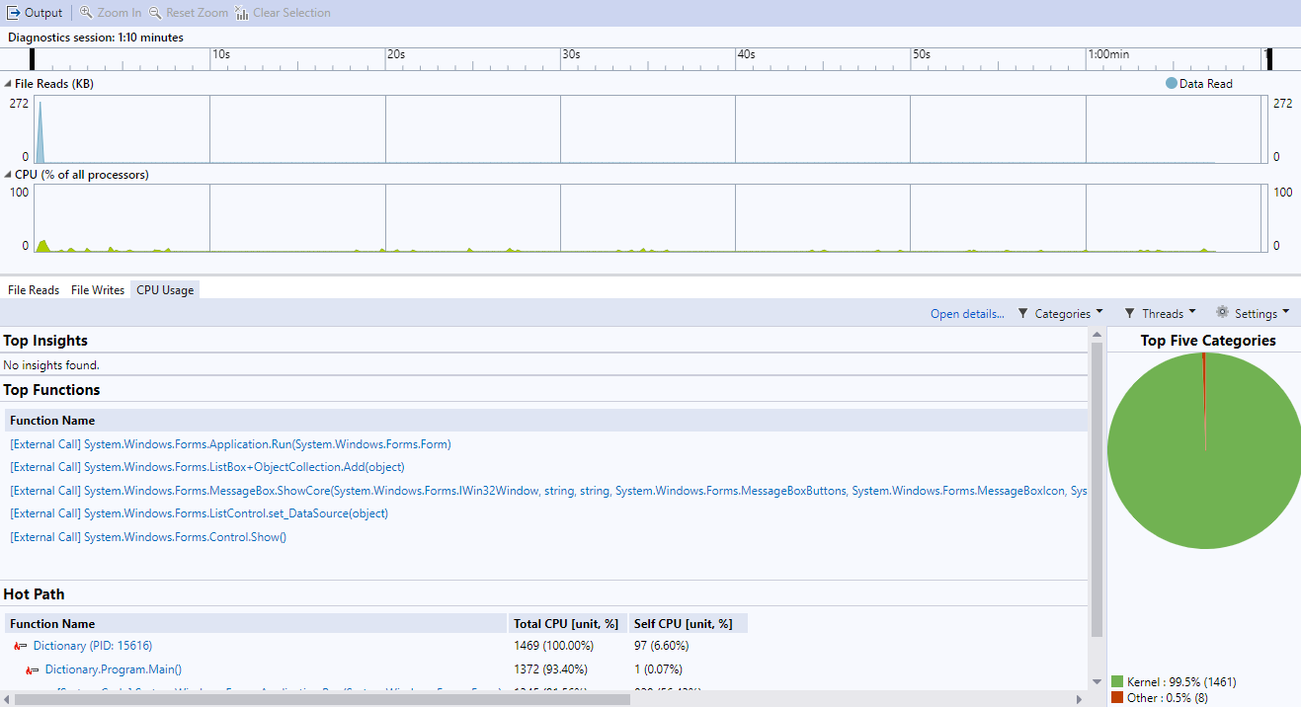

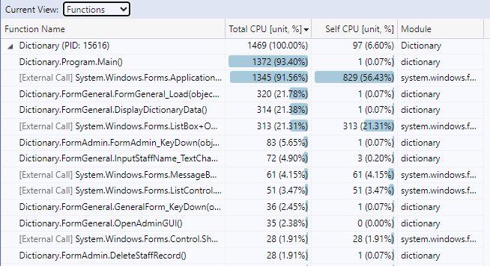

**Sorted Dictionary:**

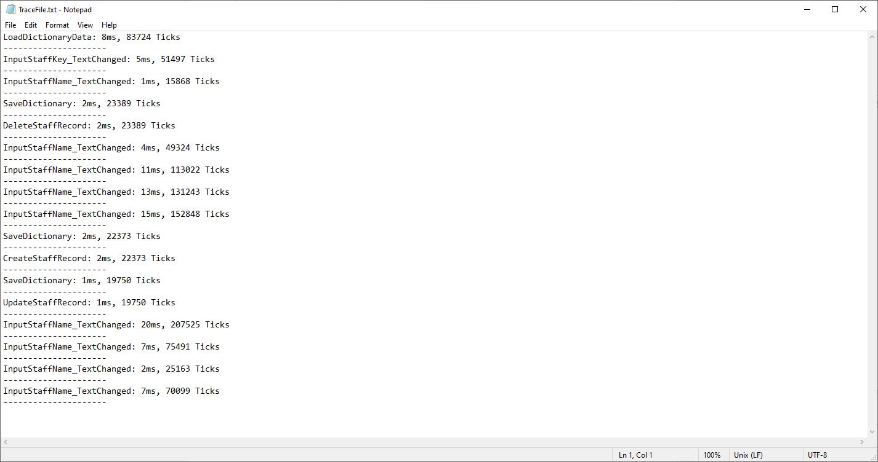

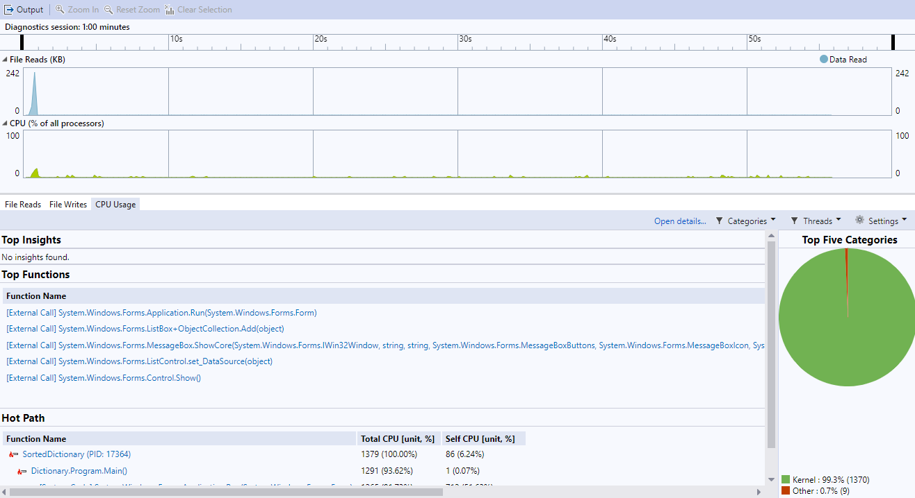

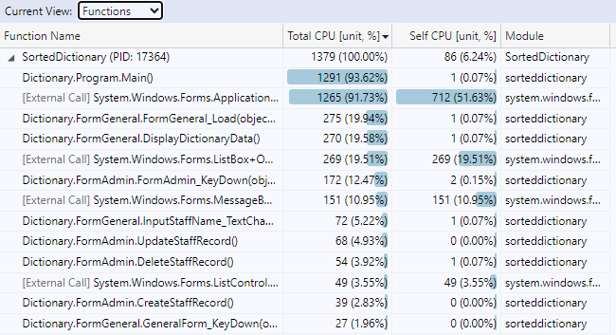

SortedDictionary is slower than Dictionary because SortedDictionary is based on Binary Search Tree. As a result, operations of both insertion and removal take longer.

Dictionary is faster than SortedDictionary because it uses a hash lookup, while your list requires walking through the list until it finds the result from beginning to the result each time.

# Question 9 Implementation Plan

Once all the development and testing has been completed you will need to consider an implementation plan. This plan will need to include a schedule (timeline), the activity/training priority and comment/feedback to ensure a trouble-free adoption of your application.

Complete the following Implementation Plan to answer this question.

|  |  |  |  |  |
| --- | --- | --- | --- | --- |
| Implementation Plan | | | | |
| Developer Name | Riley Wilson | | **Date** | 30/10/2023 |
| Week/Month | Activity/Explanation/Training | Comment/Feedback | | |
| Week One | Start implementing and testing new program | N/A | | |
| Week Two | Announce new program to staff members via email and meetings | N/A | | |
| Week Three | Train employees for new program | N/A | | |
| Week Four | Fully implement new program into the workflow | N/A | | |
|  | Add additional rows as required |  | | |

## Question 10 Demonstration, Feedback and Signoff

Ensure your code is fully commented with your Name, ID, and Date placed above the main code body of each file. Check all the above documentation has been completed and is ready for inspection. Contact your Lecturer (Assessor) and arrange to demonstrate your working applications, use the following Checklist to ensure you have completed all the assessment criteria.

|  |  |  |  |
| --- | --- | --- | --- |
| Checklist | | Completed | |
| **Questions** | | YES NO | |
| Q1 | Project Specification: all fields a have been completed |  |  |
| Q2 | Strategic Objectives Evaluation: All fields of the template are filled in. |  |  |
| Q3 | Design Approval has been signed off by Lecturer |  |  |
| Q4 | General Interface Programming Criteria (Dictionary) |  |  |
| Q5 | Admin Interface Programming Criteria |  |  |
| Q6 | General Interface Programming Criteria (SortedDictionary) |  |  |
| Q7 | Admin Interface Programming Criteria |  |  |
| Q8 | Testing and Code Optimisation: All the fields in the Report have been filled in. |  |  |
| Q9 | Implementation Plan: The plan is complete with timeline, activities and feedback |  |  |
| Q10 | Demonstration: The multi-window application is complete and all components work correctly. |  |  |

**Note:** All documentation must use the supplied templates/forms.

**Submit the zipped solution folder with relevant documents to Blackboard**

End of Assessment Three